Vertical Angle Theorem
# Source: AI Source: Provided by: [Data Path: Persons Table -> ID Column: 1, Name_En Column: Motasem Essam] -> From: [ChatGPT] on [7/25/2026]
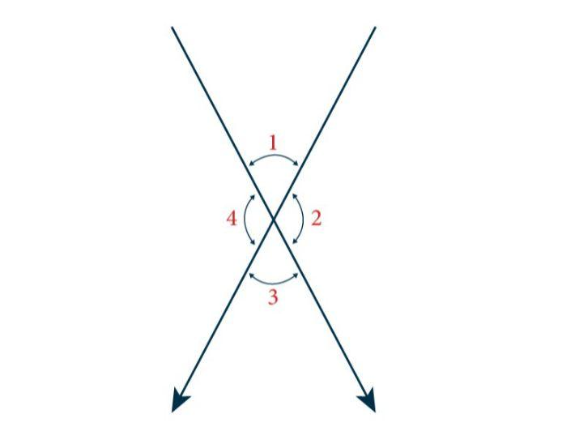​
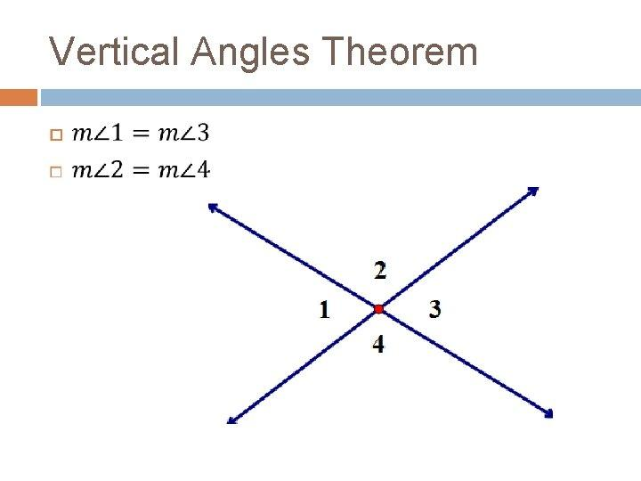​
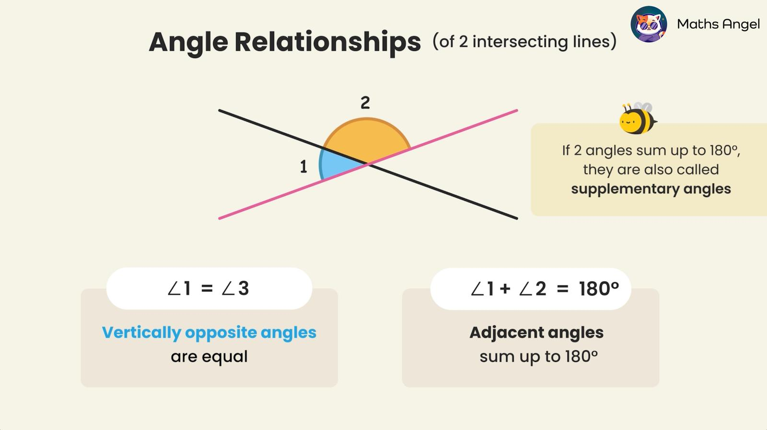​
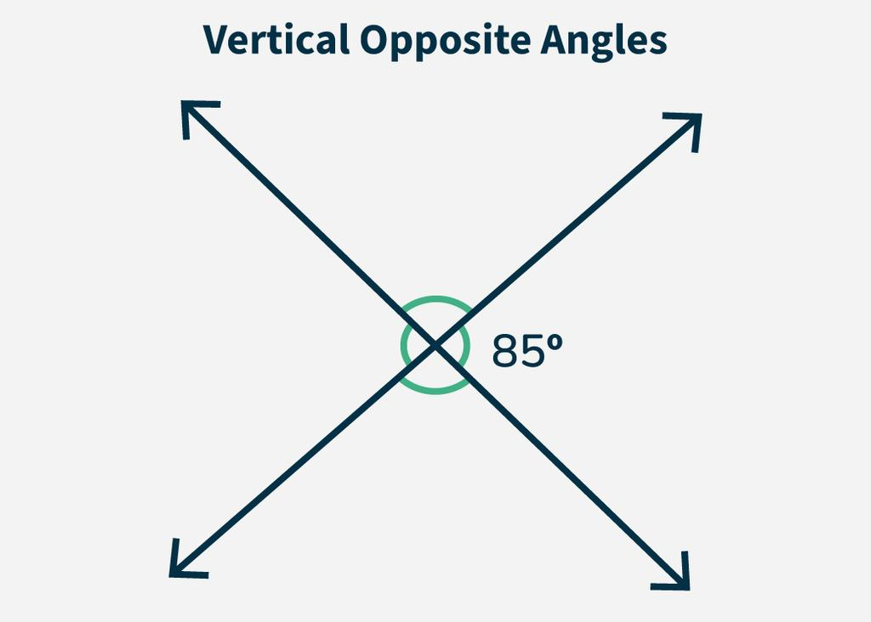​
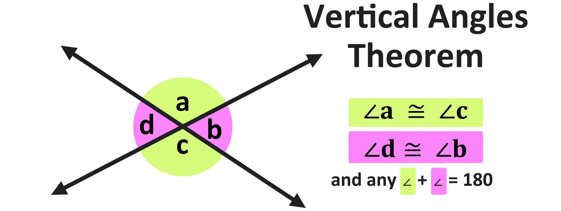

Definition
# Source: AI Source: Provided by: [Data Path: Persons Table -> ID Column: 1, Name_En Column: Motasem Essam] -> From: [ChatGPT] on [7/25/2026]
The Vertical Angle Theorem states that:
When two lines intersect, the pairs of opposite angles formed are congruent.
In other words, vertical angles always have equal measures.
If two lines intersect at point $O$, then:
$$\boxed{m∠AOC=m∠BOD}$$
and:
$$\boxed{m∠AOD=m∠BOC}$$
The angles that are opposite each other are called vertical angles.

Purpose
# Source: AI Source: Provided by: [Data Path: Persons Table -> ID Column: 1, Name_En Column: Motasem Essam] -> From: [ChatGPT] on [7/25/2026]
The Vertical Angle Theorem is used to:
- Find unknown angle measures.
- Establish that two angles are congruent.
- Solve geometric equations.
- Analyze intersecting lines.
- Determine relationships between adjacent and opposite angles.
- Solve problems involving triangles, polygons, and transversals.

Basic Configuration
# Source: AI Source: Provided by: [Data Path: Persons Table -> ID Column: 1, Name_En Column: Motasem Essam] -> From: [ChatGPT] on [7/25/2026]
Consider two intersecting lines:
$$A→O→C$$
and:
$$B→O→D$$
They form four angles:
$$∠AOB, ∠BOC, ∠COD, ∠DOA$$
The opposite pairs are:
$$\boxed{∠AOB≅∠COD}$$
and:
$$\boxed{∠BOC≅∠DOA}$$
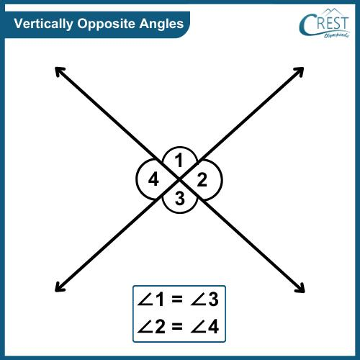​
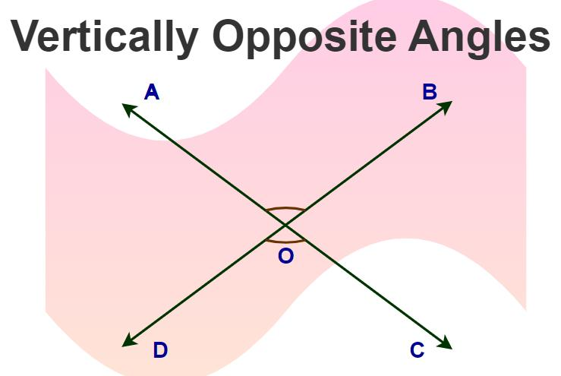​
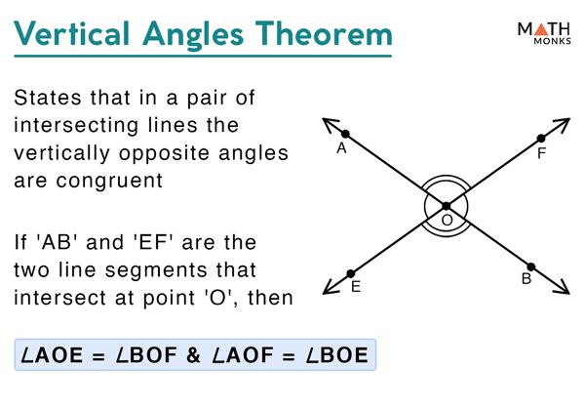​
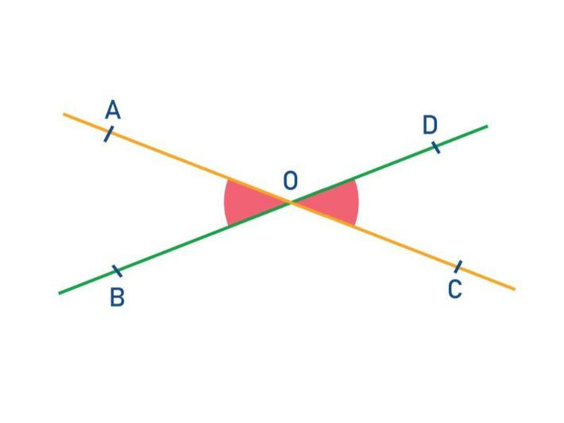

Mathematical Representation
# Source: AI Source: Provided by: [Data Path: Persons Table -> ID Column: 1, Name_En Column: Motasem Essam] -> From: [ChatGPT] on [7/25/2026]
For two intersecting lines:
$$\boxed{m∠1=m∠3}$$
and:
$$\boxed{m∠2=m∠4}$$
where $∠1$ and $∠3$ are opposite, and $∠2$ and $∠4$ are opposite.
Therefore:
$$\boxed{\text{Vertical angles are congruent.}}$$

Example 1 — Finding an Unknown Angle
# Source: AI Source: Provided by: [Data Path: Persons Table -> ID Column: 1, Name_En Column: Motasem Essam] -> From: [ChatGPT] on [7/25/2026]
Suppose two lines intersect and:
$$m∠1={65}^{∘}$$
Find the vertical angle $∠3$.
Since $∠1$ and $∠3$ are vertical angles:
$$m∠1=m∠3$$
Therefore:
$$\boxed{m∠3={65}^{∘}}$$

Example 2 — Algebraic Angles
# Source: AI Source: Provided by: [Data Path: Persons Table -> ID Column: 1, Name_En Column: Motasem Essam] -> From: [ChatGPT] on [7/25/2026]
Suppose two vertical angles have measures:
$$m∠1=3x+10$$
and:
$$m∠3=5x-20$$
Because they are vertical angles:
$$3x+10=5x-20$$
Solve:
$$30=2x$$
$$x=15$$
Now calculate the angle:
$$m∠1=3(15)+10$$
$$m∠1={55}^{∘}$$
Therefore:
$$\boxed{x=15}$$
and:
$$\boxed{m∠1=m∠3={55}^{∘}}$$

Example 3 — Using Adjacent Angles
# Source: AI Source: Provided by: [Data Path: Persons Table -> ID Column: 1, Name_En Column: Motasem Essam] -> From: [ChatGPT] on [7/25/2026]
Suppose one angle is:
$${120}^{∘}$$
Its vertical angle is also:
$$\boxed{{120}^{∘}}$$
The angles adjacent to it form linear pairs, so each adjacent angle is:
$${180}^{∘}-{120}^{∘}={60}^{∘}$$
Thus, the four angles are:
$$\boxed{{120}^{∘}, {60}^{∘}, {120}^{∘}, {60}^{∘}}$$
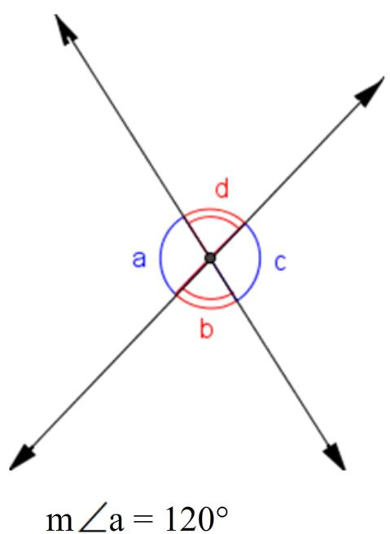​
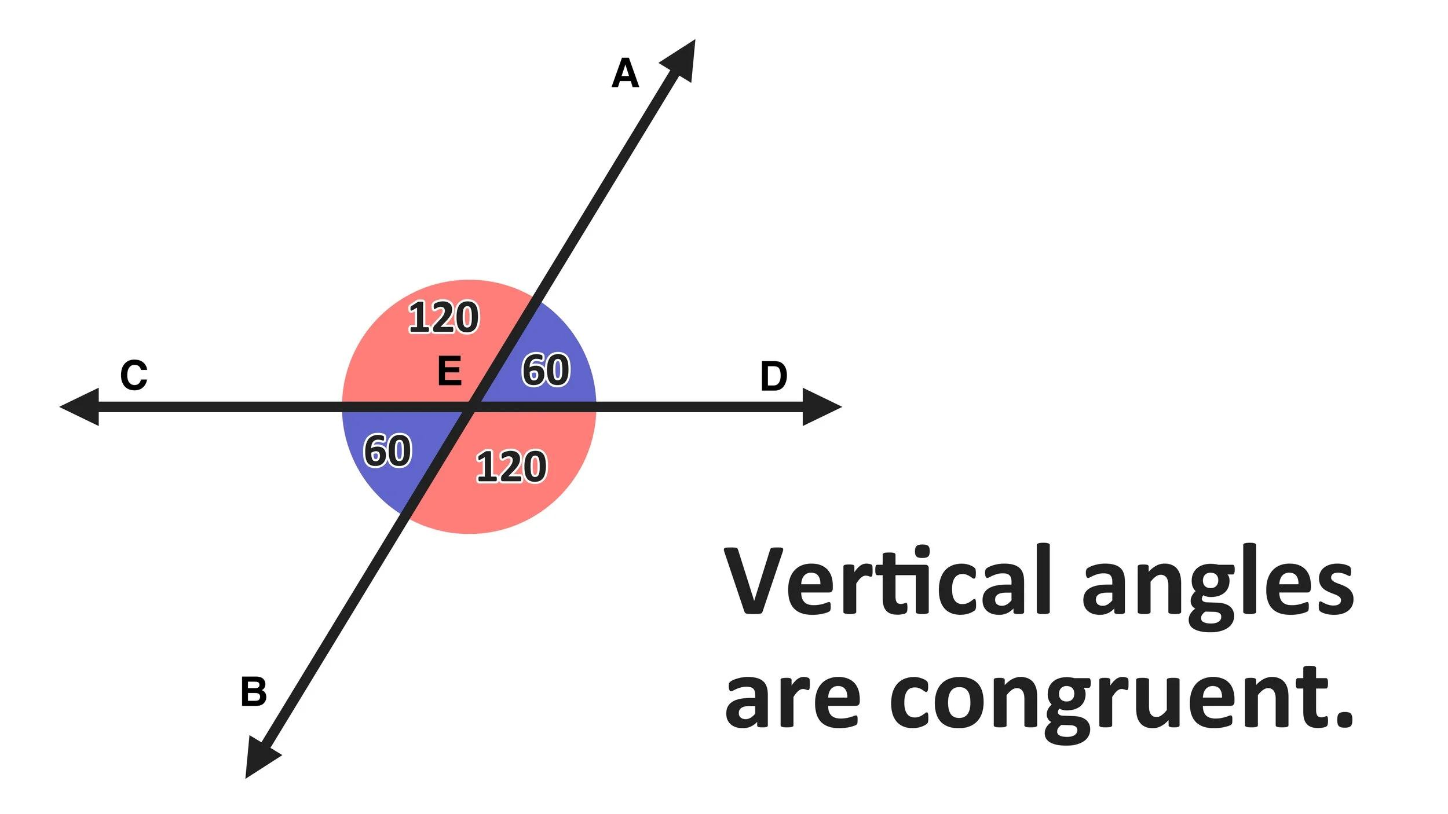​
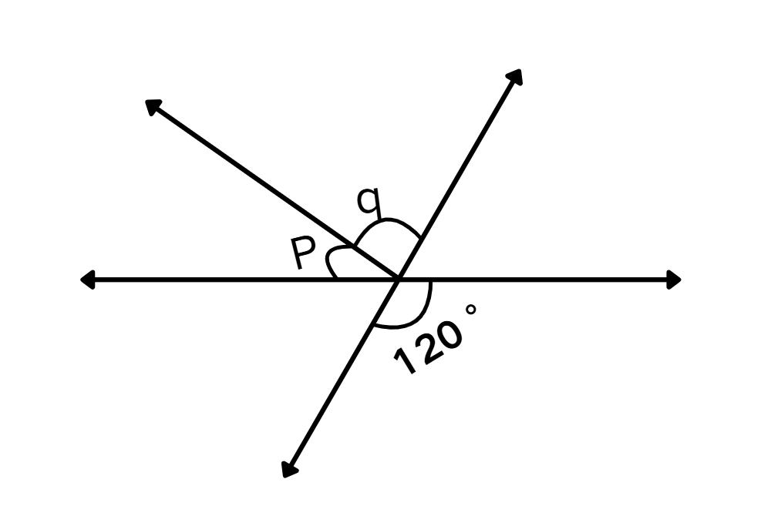​
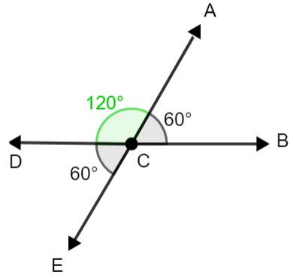​
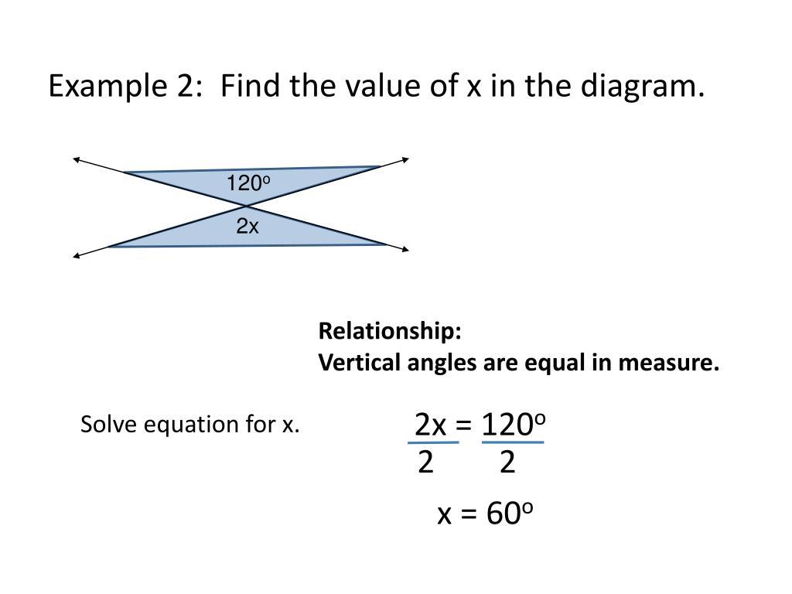

Why Are Vertical Angles Equal?
# Source: AI Source: Provided by: [Data Path: Persons Table -> ID Column: 1, Name_En Column: Motasem Essam] -> From: [ChatGPT] on [7/25/2026]
The equality follows from the Linear Pair Postulate.
Suppose two intersecting lines create four angles.
Two adjacent angles form a straight angle, so their measures add to:
$${180}^{∘}$$
For example:
$$m∠1+m∠2={180}^{∘}$$
Also:
$$m∠2+m∠3={180}^{∘}$$
Therefore:
$$m∠1+m∠2=m∠2+m∠3$$
Subtract $m∠2$ from both sides:
$$\boxed{m∠1=m∠3}$$
Thus, the vertical angles are congruent.

Proof of the Vertical Angle Theorem
# Source: AI Source: Provided by: [Data Path: Persons Table -> ID Column: 1, Name_En Column: Motasem Essam] -> From: [ChatGPT] on [7/25/2026]
Suppose two lines intersect at $O$.
Consider $∠1$ and $∠3$, which are vertical angles.
Because $∠1$ and $∠2$ form a linear pair:
$$m∠1+m∠2={180}^{∘}$$
Because $∠2$ and $∠3$ also form a linear pair:
$$m∠2+m∠3={180}^{∘}$$
Therefore:
$$m∠1+m∠2=m∠2+m∠3$$
Subtract $m∠2$:
$$\boxed{m∠1=m∠3}$$
Therefore:
$$\boxed{∠1≅∠3}$$
The same reasoning proves:
$$\boxed{∠2≅∠4}$$

Important Properties
# Source: AI Source: Provided by: [Data Path: Persons Table -> ID Column: 1, Name_En Column: Motasem Essam] -> From: [ChatGPT] on [7/25/2026]
1. Vertical angles are congruent
$$\boxed{m∠1=m∠3}$$
2. Vertical angles are opposite
They do not share a common side.
3. Vertical angles share the same vertex
Both angles have the intersection point as their vertex.
4. Adjacent angles are not vertical angles
Adjacent angles share a side and vertex.
5. Vertical angles are formed by intersecting lines
Two intersecting lines always create two pairs of vertical angles.

Vertical Angles vs. Adjacent Angles
# Source: AI Source: Provided by: [Data Path: Persons Table -> ID Column: 1, Name_En Column: Motasem Essam] -> From: [ChatGPT] on [7/25/2026]
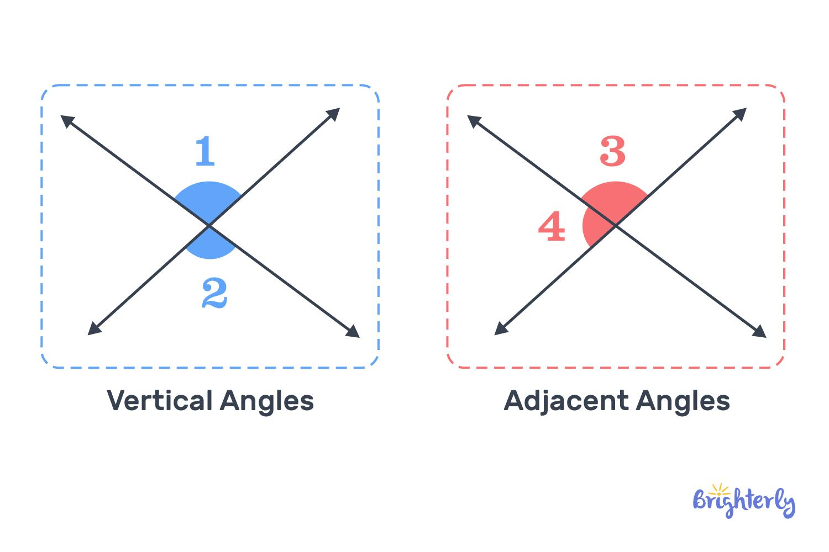
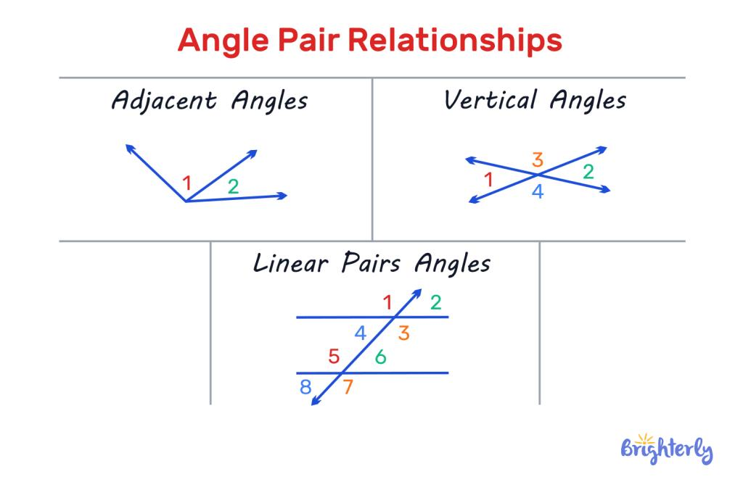​
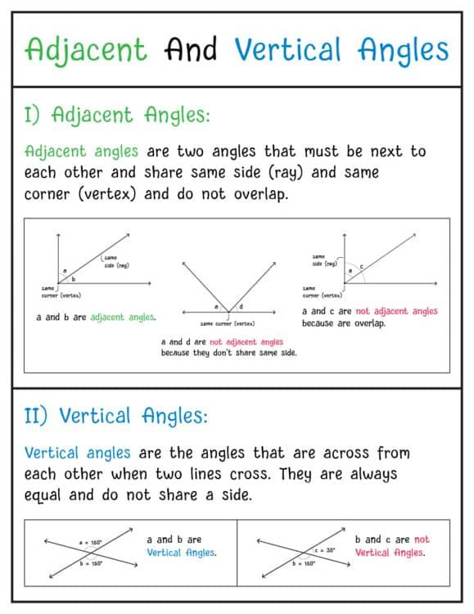
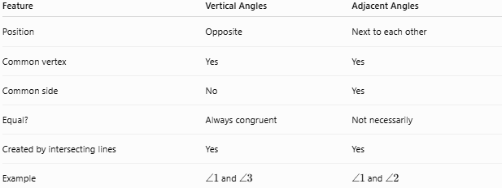
Feature | Vertical Angles | Adjacent Angles
Position | Opposite | Next to each other
Common vertex | Yes | Yes
Common side | No | Yes
Equal? | Always congruent | Not necessarily
Created by intersecting lines | Yes | Yes
Example | $∠1$ and $∠3$ | $∠1$ and $∠2$

Relationship with Linear Pairs
# Source: AI Source: Provided by: [Data Path: Persons Table -> ID Column: 1, Name_En Column: Motasem Essam] -> From: [ChatGPT] on [7/25/2026]
Vertical angles and linear pairs occur together when two lines intersect.
If:
$$m∠1={70}^{∘}$$
then its vertical angle is:
$$m∠3={70}^{∘}$$
The adjacent angles must be:
$${180}^{∘}-{70}^{∘}={110}^{∘}$$
Therefore:
$$\boxed{{70}^{∘}, {110}^{∘}, {70}^{∘}, {110}^{∘}}$$
So, for two intersecting lines:
$$\boxed{\text{Vertical angles are equal}}$$
while:
$$\boxed{\text{Adjacent linear-pair angles are supplementary}}$$

Special Cases

Perpendicular Lines
# Source: AI Source: Provided by: [Data Path: Persons Table -> ID Column: 1, Name_En Column: Motasem Essam] -> From: [ChatGPT] on [7/25/2026]
If two lines are perpendicular, all four angles are right angles:
$$\boxed{{90}^{∘}, {90}^{∘}, {90}^{∘}, {90}^{∘}}$$
The vertical angle theorem still applies:
$${90}^{∘}={90}^{∘}$$

Acute and Obtuse Angles
# Source: AI Source: Provided by: [Data Path: Persons Table -> ID Column: 1, Name_En Column: Motasem Essam] -> From: [ChatGPT] on [7/25/2026]
If two intersecting lines are not perpendicular, there will be:
- Two equal acute angles.
- Two equal obtuse angles.
For example:
$${60}^{∘}, {120}^{∘}, {60}^{∘}, {120}^{∘}$$
The opposite angles are always equal.

Applications
# Source: AI Source: Provided by: [Data Path: Persons Table -> ID Column: 1, Name_En Column: Motasem Essam] -> From: [ChatGPT] on [7/25/2026]
The Vertical Angle Theorem is used in:
- Plane geometry.
- Triangle problems.
- Parallel-line problems.
- Transversal problems.
- Coordinate geometry.
- Algebraic angle problems.
- Construction and drafting.
- Engineering diagrams.
- Architecture.
- Computer graphics.

Common Mistakes

Mistake 1 — Confusing vertical with adjacent
# Source: AI Source: Provided by: [Data Path: Persons Table -> ID Column: 1, Name_En Column: Motasem Essam] -> From: [ChatGPT] on [7/25/2026]
Vertical angles are opposite, not next to each other.

Mistake 2 — Assuming all four angles are equal
# Source: AI Source: Provided by: [Data Path: Persons Table -> ID Column: 1, Name_En Column: Motasem Essam] -> From: [ChatGPT] on [7/25/2026]
They are not necessarily all equal.
For example:
$${60}^{∘}, {120}^{∘}, {60}^{∘}, {120}^{∘}$$
Only opposite pairs are equal.

Mistake 3 — Forgetting the linear-pair relationship
# Source: AI Source: Provided by: [Data Path: Persons Table -> ID Column: 1, Name_En Column: Motasem Essam] -> From: [ChatGPT] on [7/25/2026]
Adjacent angles formed by intersecting lines add to:
$${180}^{∘}$$

Comparison with Related Concepts
# Source: AI Source: Provided by: [Data Path: Persons Table -> ID Column: 1, Name_En Column: Motasem Essam] -> From: [ChatGPT] on [7/25/2026]
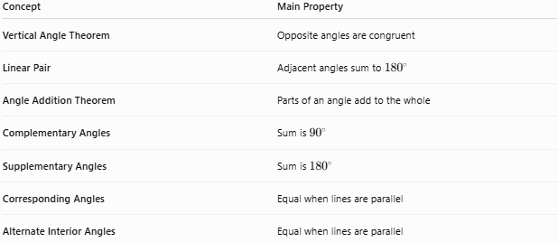
Concept | Main Property
Vertical Angle Theorem | Opposite angles are congruent
Linear Pair | Adjacent angles sum to ${180}^{∘}$
Angle Addition Theorem | Parts of an angle add to the whole
Complementary Angles | Sum is ${90}^{∘}$
Supplementary Angles | Sum is ${180}^{∘}$
Corresponding Angles | Equal when lines are parallel
Alternate Interior Angles | Equal when lines are parallel

Key Points
# Source: AI Source: Provided by: [Data Path: Persons Table -> ID Column: 1, Name_En Column: Motasem Essam] -> From: [ChatGPT] on [7/25/2026]
- Vertical angles are formed when two lines intersect.
- They are opposite angles.
- They share a vertex but do not share a side.
- Vertical angles are always congruent:
$$\boxed{m∠1=m∠3}$$
$$\boxed{m∠2=m∠4}$$
- Adjacent angles form linear pairs and therefore sum to:
$$\boxed{{180}^{∘}}$$
- If one angle is known, its vertical angle has the same measure.
- If one angle is $x^{∘}$, its vertical angle is also $x^{∘}$.

Conclusion
# Source: AI Source: Provided by: [Data Path: Persons Table -> ID Column: 1, Name_En Column: Motasem Essam] -> From: [ChatGPT] on [7/25/2026]
The Vertical Angle Theorem states that when two lines intersect, the opposite angles formed are congruent:
$$\boxed{\text{Vertical Angles}=\text{Equ}\text{al}\text{ Angles}}$$
For two intersecting lines:
$$\boxed{m∠1=m∠3}$$
and:
$$\boxed{m∠2=m∠4}$$
This theorem is fundamental in geometry and is especially useful together with the Linear Pair Postulate, Angle Addition Theorem, and theorems involving parallel lines and transversals.

